
Richard Bangs’ Adventures with Purpose
Morocco: Quest for the Kasbah & Norway: Quest for the Viking Spirit
Photos and Captions:
High resolution JPG files of these and other photos may be downloaded from the press section of www.AdventuresWithPurpose.tv. Photo files and captions are also on the enclosed press kit CD-ROM.
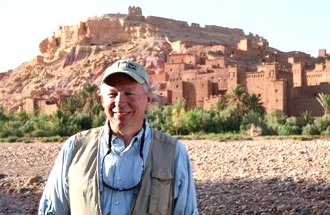
Richard Bangs pauses at Ait Benhaddou Kasbah in Morocco during the filming of Adventures with Purpose—Morocco: Quest for the Kasbah. “Meet me at the Kasbah,” has become an evocative invitation in today’s vernacular, but what is the modern equivalent of this ancient vault, and where is it found? This one-hour documentary special follows Richard as he seeks to discover the meaning of the modern Kasbah and what it might represent for modern Morocco and the world. Richard Bangs is often called the father of modern adventure travel. Leader of 35 first descents of rivers around the globe, a mountain climber and renowned author, Richard brings a lifetime of experience to Adventures with Purpose. The series is produced by Small World Productions of Seattle and co-produced by KCTS/Seattle and Richard Bangs Productions of Marina del Rey, California.

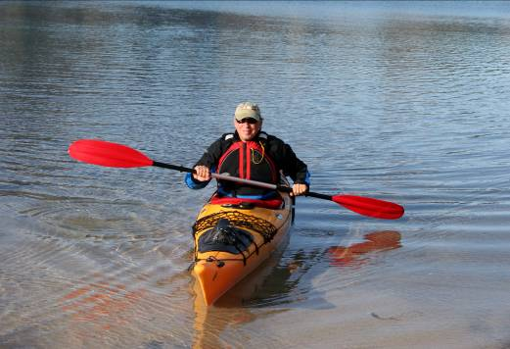
Modern explorer Richard Bangs kayaks on a Norwegian fjord in his latest special, Adventures with Purpose—Norway: Quest for the Viking Spirit. A thousand years ago Vikings set out from these fjords striking fear across Europe. Yet today this ruggedly beautiful country is the home of the Nobel Peace Center, of explorers and adventure travelers and is one of the most eco-friendly countries on earth. Bangs’ quest is to discover how such a progressive nation grew from such a violent past. Bangs is host and co-executive producer for Adventures with Purpose, a series of one-hour documentaries from American Public Television. Richard has published more than 1000 magazine articles, 18 books, a score of documentaries and several CD-ROMs; and has lectured at the Smithsonian, the National Geographic Society, the Explorers Club and many other notable venues. He writes a semi-regular feature with the New York Times and was recently honored with a Lowell Thomas Award for travel journalism.

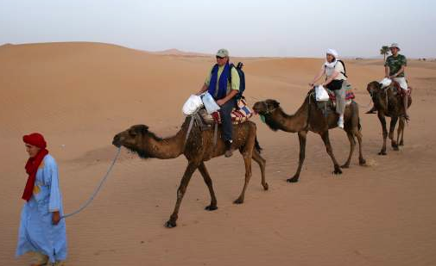
Renowned writer and adventurer Richard Bangs treks into the Sarah Dessert in “Morocco: Quest for the Kasbah” a new, one-hour special from American Public Television. As he explores Morocco, an intoxicating intersection of great civilizations, Bangs seeks to discover the meaning of the modern Kasbah and what it might represent for modern Morocco and the world. Leader of 35 first descents of rivers around the globe, a mountain climber and renowned author, Richard brings a lifetime of experience to Adventures with Purpose. Morocco: Quest for the Kasbah is the latest episode in this series of one-hour documentaries produced by Small World Productions of Seattle and co-produced by KCTS/Seattle and Richard Bangs Productions of Marina del Rey, California. American Public Television of Boston distributes this award-winning series to more than 250 public stations nationally.

These and additional photos may be downloaded from the press section of www.AdventuresWithPurpose.tv
Richard Bangs’ Adventures with Purpose are sponsored in part by Exofficio Travel Apparel—www.Exofficio.com.

Small World Productions
140 Lakeside Avenue, Suite 200
Seattle, WA, USA 98122

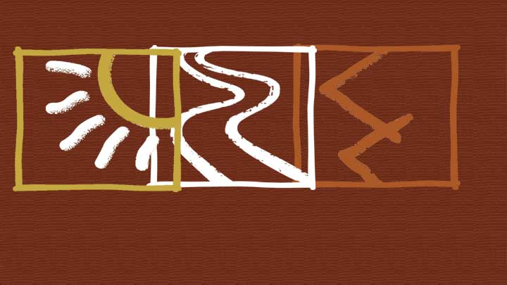
Morocco: Quest for the Kasbah
Norway: Quest for the Viking Spirit
